Test Case: tc005_SPX_Dev5_Crear_Requisicion_Spot_Con_FAD_Tipo_Cobro_Project
Step 1 - Enter username and password and click to button Enter: Credentials Entered
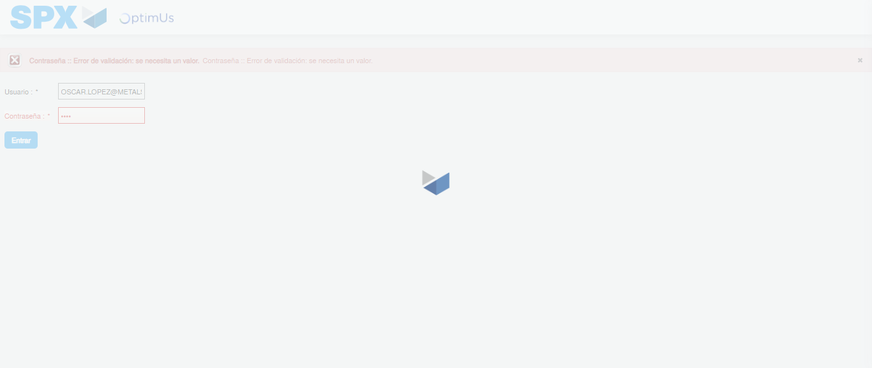Image file-name: QC_Testing-tc005_SPX_Dev5_Crear_Requisicion_Spot_Con_FAD_Tipo_Cobro_Project-1784571031158

Step 2 - Select to UEN and Access to Spot Buy Requisitions : UEN Correctly selected and Correct access
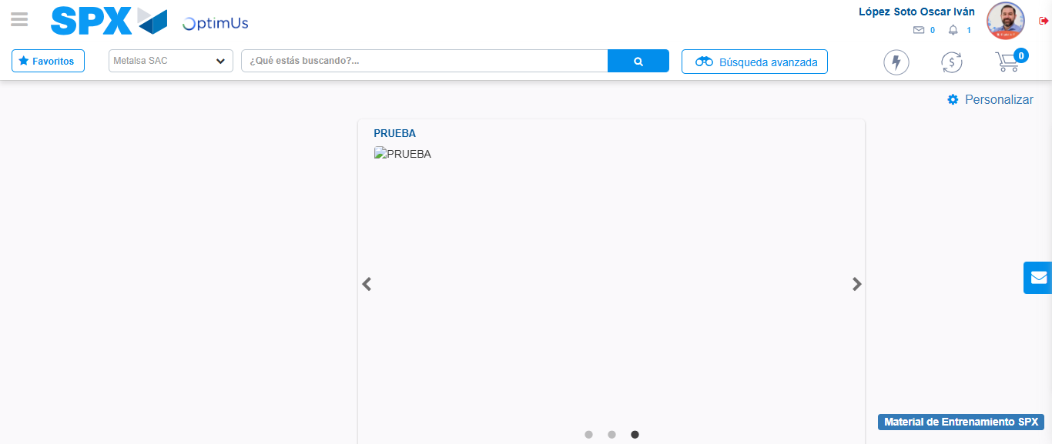Image file-name: QC_Testing-tc005_SPX_Dev5_Crear_Requisicion_Spot_Con_FAD_Tipo_Cobro_Project-1784571097868

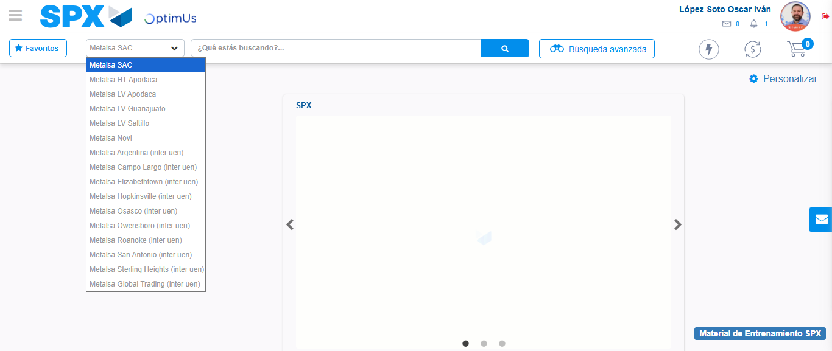Image file-name: QC_Testing-tc005_SPX_Dev5_Crear_Requisicion_Spot_Con_FAD_Tipo_Cobro_Project-1784571100654

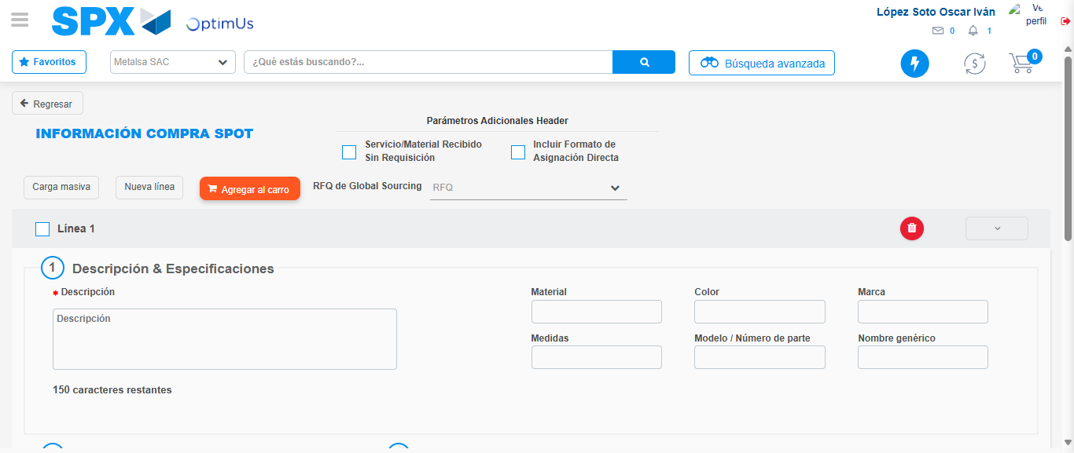Image file-name: QC_Testing-tc005_SPX_Dev5_Crear_Requisicion_Spot_Con_FAD_Tipo_Cobro_Project-1784571115507

Step 3 - Add FAD to Requisition: FAD Successfully Added
Image file-name: QC_Testing-tc005_SPX_Dev5_Crear_Requisicion_Spot_Con_FAD_Tipo_Cobro_Project-1784571115765

Image file-name: QC_Testing-tc005_SPX_Dev5_Crear_Requisicion_Spot_Con_FAD_Tipo_Cobro_Project-1784571115978

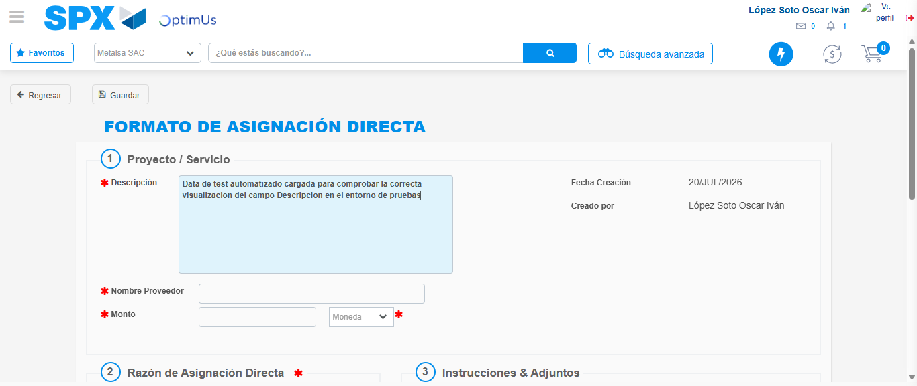Image file-name: QC_Testing-tc005_SPX_Dev5_Crear_Requisicion_Spot_Con_FAD_Tipo_Cobro_Project-1784571119040

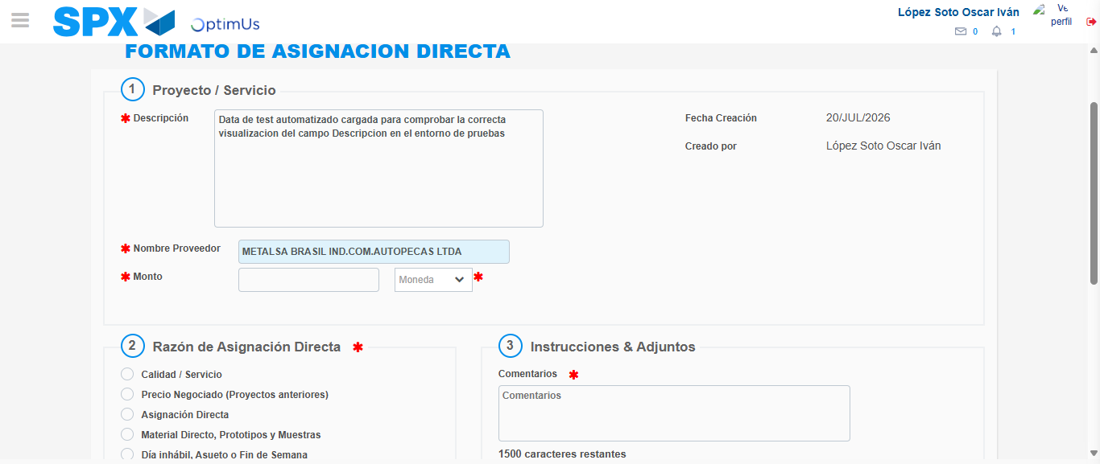Image file-name: QC_Testing-tc005_SPX_Dev5_Crear_Requisicion_Spot_Con_FAD_Tipo_Cobro_Project-1784571125884

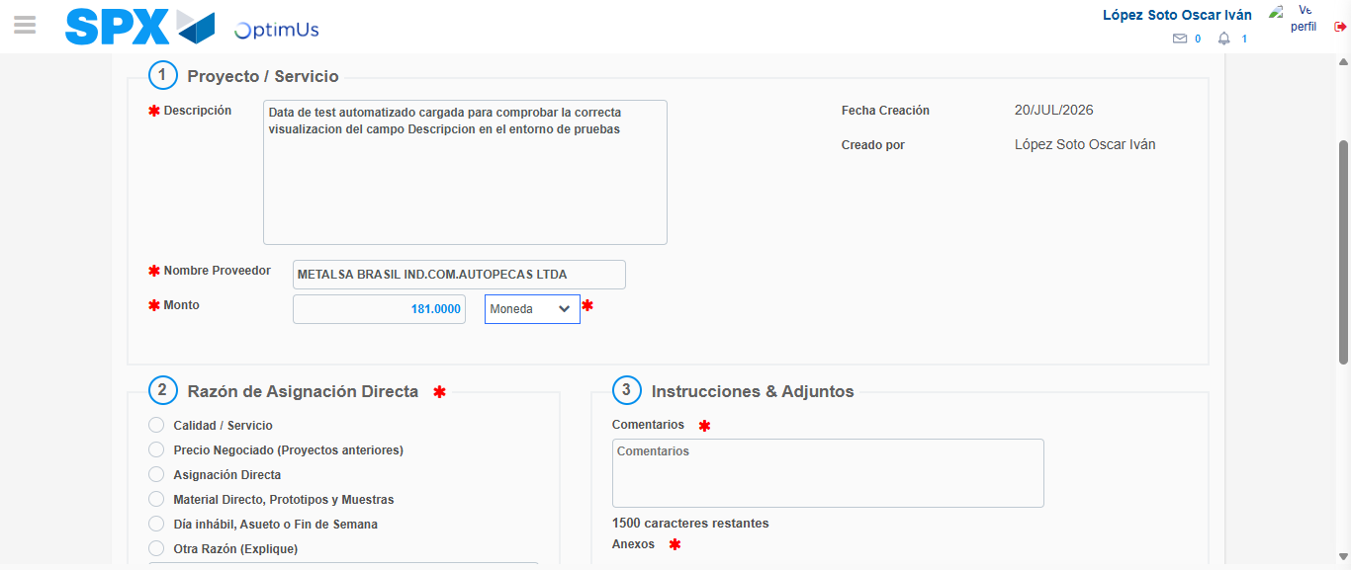Image file-name: QC_Testing-tc005_SPX_Dev5_Crear_Requisicion_Spot_Con_FAD_Tipo_Cobro_Project-1784571126413

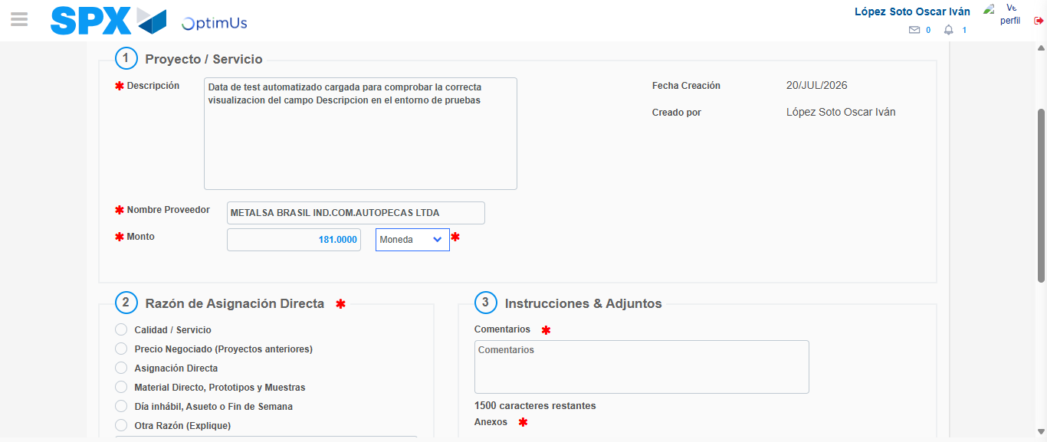Image file-name: QC_Testing-tc005_SPX_Dev5_Crear_Requisicion_Spot_Con_FAD_Tipo_Cobro_Project-1784571126668

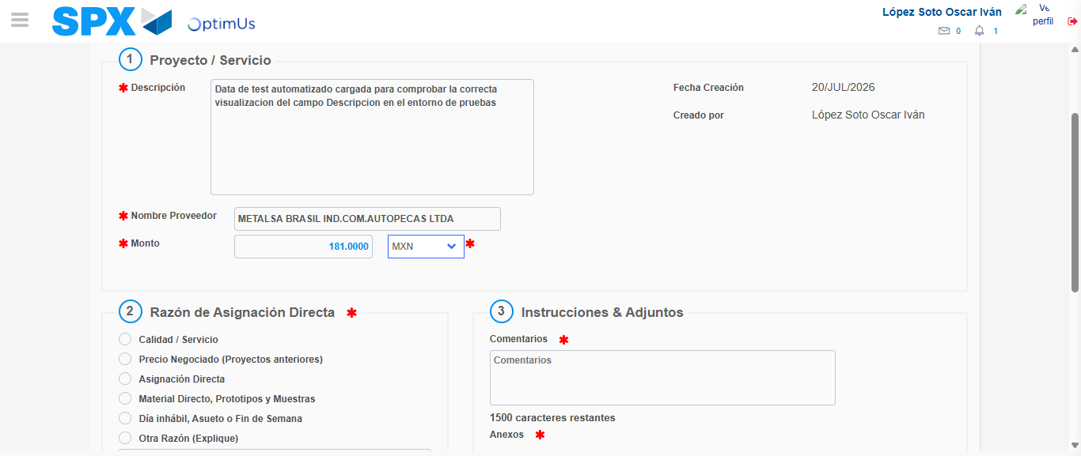Image file-name: QC_Testing-tc005_SPX_Dev5_Crear_Requisicion_Spot_Con_FAD_Tipo_Cobro_Project-1784571127161

Image file-name: QC_Testing-tc005_SPX_Dev5_Crear_Requisicion_Spot_Con_FAD_Tipo_Cobro_Project-1784571127398

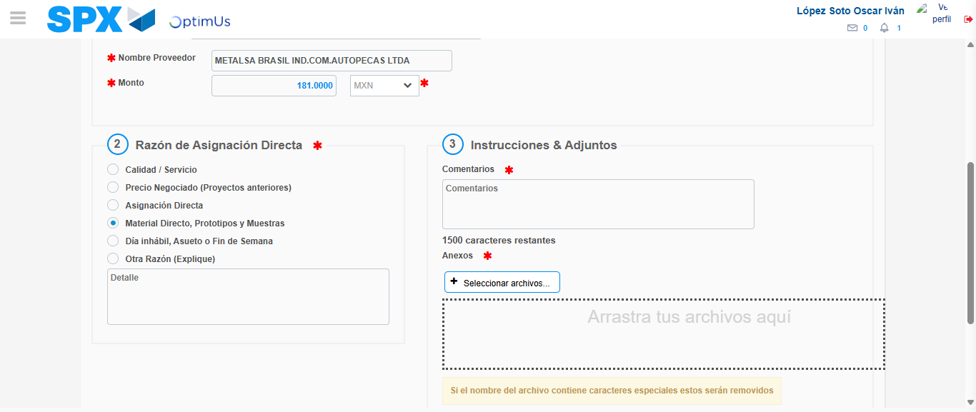Image file-name: QC_Testing-tc005_SPX_Dev5_Crear_Requisicion_Spot_Con_FAD_Tipo_Cobro_Project-1784571128350

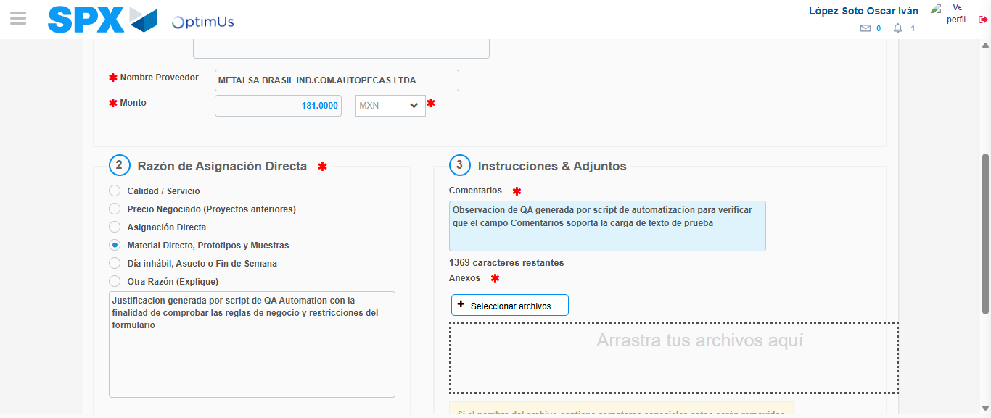Image file-name: QC_Testing-tc005_SPX_Dev5_Crear_Requisicion_Spot_Con_FAD_Tipo_Cobro_Project-1784571139805

Image file-name: QC_Testing-tc005_SPX_Dev5_Crear_Requisicion_Spot_Con_FAD_Tipo_Cobro_Project-1784571140700

Step 4 - Data Capture Spot Buy Requisition: Data captured correctly
Image file-name: QC_Testing-tc005_SPX_Dev5_Crear_Requisicion_Spot_Con_FAD_Tipo_Cobro_Project-1784571115765

Image file-name: QC_Testing-tc005_SPX_Dev5_Crear_Requisicion_Spot_Con_FAD_Tipo_Cobro_Project-1784571115978

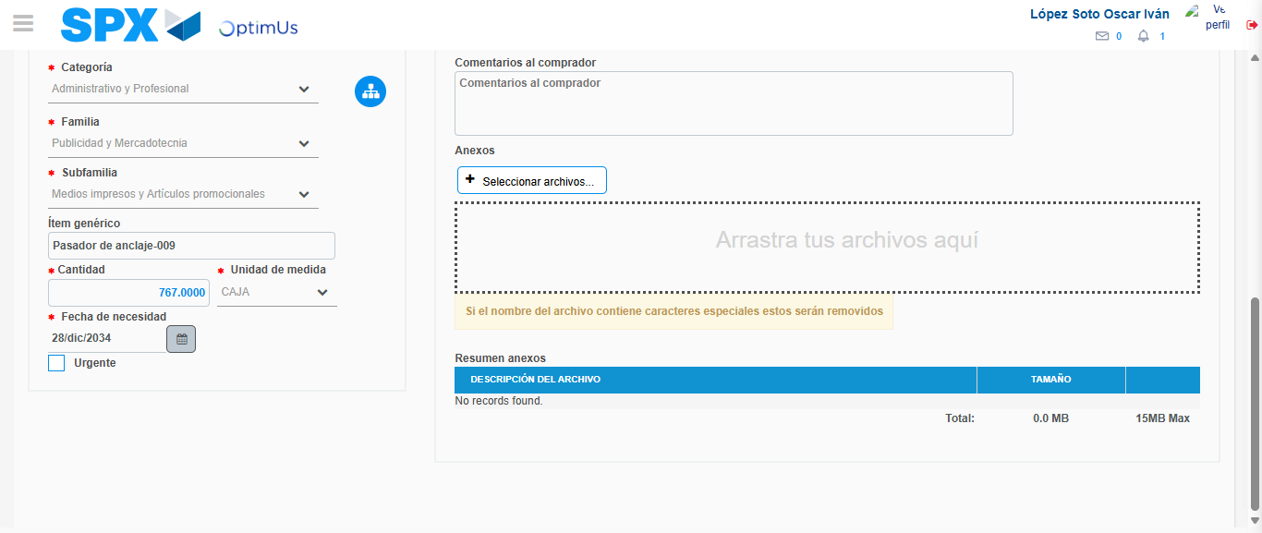Image file-name: QC_Testing-tc005_SPX_Dev5_Crear_Requisicion_Spot_Con_FAD_Tipo_Cobro_Project-1784571154903

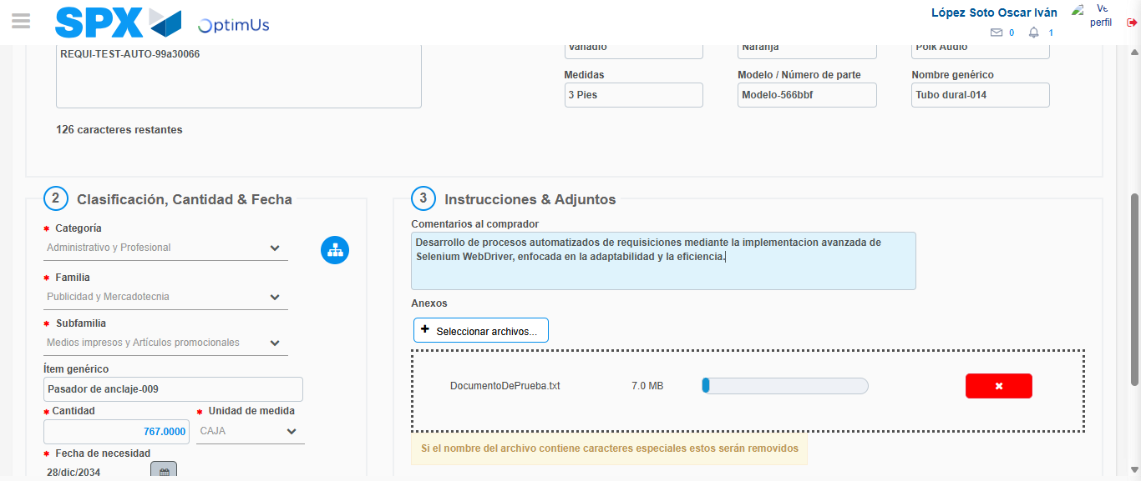Image file-name: QC_Testing-tc005_SPX_Dev5_Crear_Requisicion_Spot_Con_FAD_Tipo_Cobro_Project-1784571155857

Step 8 - Return to Main Page SPX : Return to Main Page SPX
Image file-name: QC_Testing-tc005_SPX_Dev5_Crear_Requisicion_Spot_Con_FAD_Tipo_Cobro_Project-1784571097868

Image file-name: QC_Testing-tc005_SPX_Dev5_Crear_Requisicion_Spot_Con_FAD_Tipo_Cobro_Project-1784571100654

Image file-name: QC_Testing-tc005_SPX_Dev5_Crear_Requisicion_Spot_Con_FAD_Tipo_Cobro_Project-1784571115507

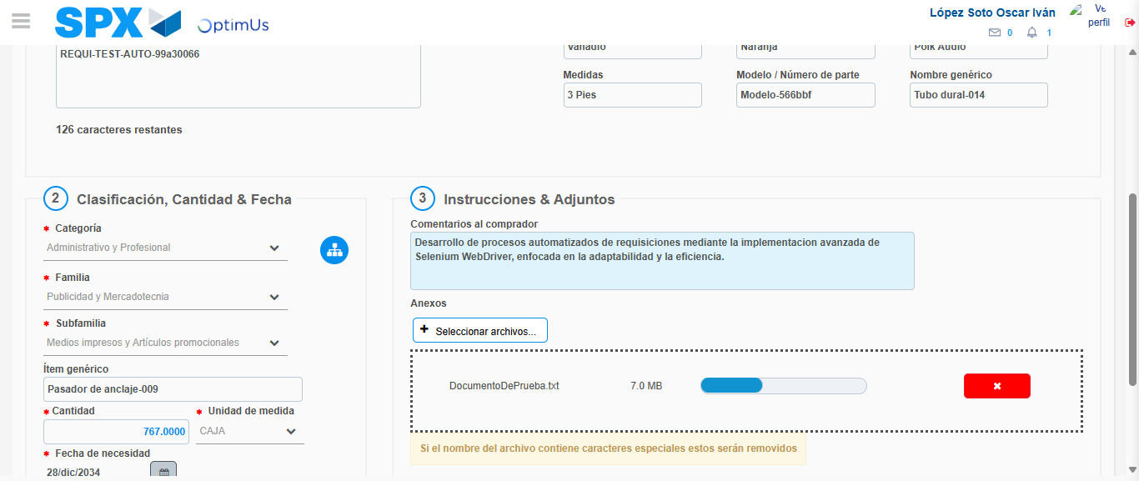Image file-name: QC_Testing-tc005_SPX_Dev5_Crear_Requisicion_Spot_Con_FAD_Tipo_Cobro_Project-1784571158135

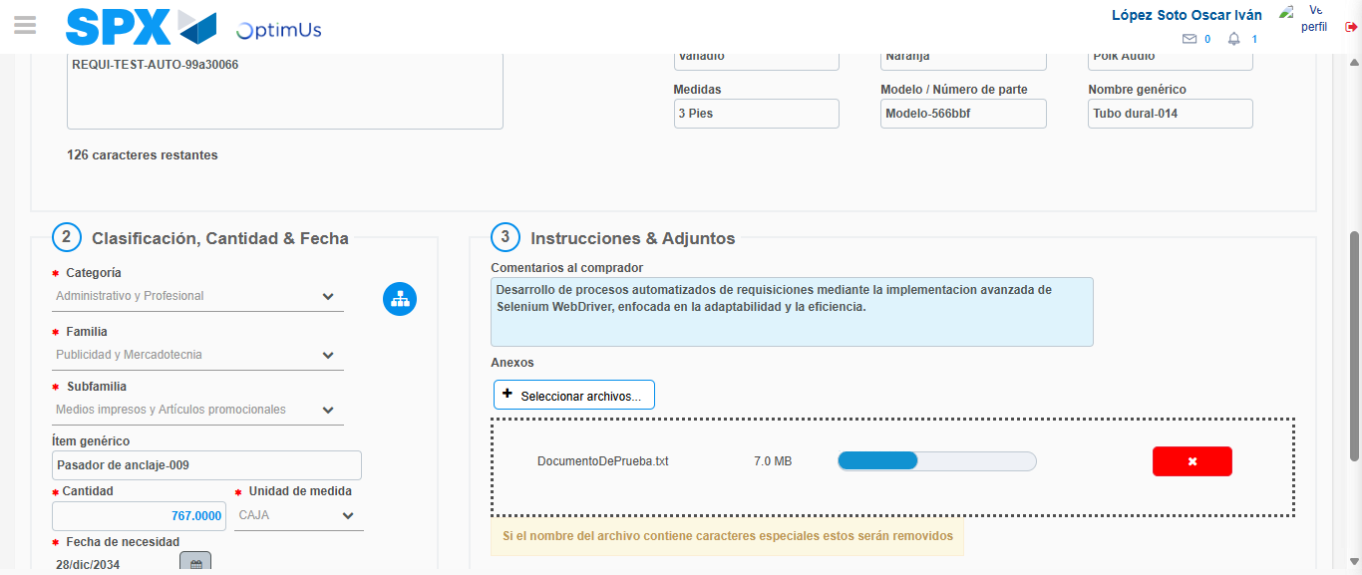Image file-name: QC_Testing-tc005_SPX_Dev5_Crear_Requisicion_Spot_Con_FAD_Tipo_Cobro_Project-1784571158359

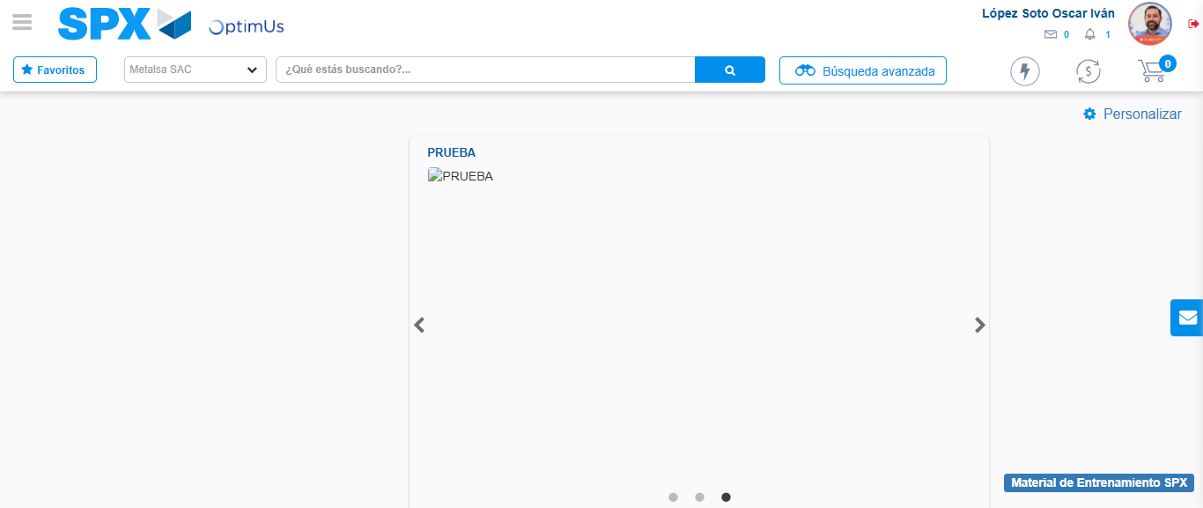Image file-name: QC_Testing-tc005_SPX_Dev5_Crear_Requisicion_Spot_Con_FAD_Tipo_Cobro_Project-1784571180550

Step 9 - Log Out : Log Out SPX
Image file-name: QC_Testing-tc005_SPX_Dev5_Crear_Requisicion_Spot_Con_FAD_Tipo_Cobro_Project-1784571180780

